Wireshark Lab: IP

In this lab, we’ll investigate the IP protocol, focusing on the IP datagram. We’ll do so by analyzing a trace of IP datagrams sent and received by an execution of the traceroute program (the traceroute program itself is explored in more detail in the Wireshark ICMP lab). We’ll investigate the various fields in the IP datagram, and study IP fragmentation in detail.

Capturing packets from an execution of traceroute
In order to generate a trace of IP datagrams for this lab, we’ll use the traceroute program to send datagrams of different sizes towards some destination, X. Recall that traceroute operates by first sending one or more datagrams with the time-to-live (TTL) field in the IP header set to 1; it then sends a series of one or more datagrams towards the same destination with a TTL value of 2; it then sends a series of datagrams towards the same destination with a TTL value of 3; and so on. Recall that a router must decrement the TTL in each received datagram by 1 (actually, RFC 791 says that the router must decrement the TTL by at least one). If the TTL reaches 0, the router returns an ICMP message (type 11 – TTL-exceeded) to the sending host. As a result of this behavior, a datagram with a TTL of 1 (sent by the host executing traceroute) will cause the router one hop away from the sender to send an ICMP TTL-exceeded message back to the sender; the datagram sent with a TTL of 2 will cause the router two hops away to send an ICMP message back to the sender; the datagram sent with a TTL of 3 will cause the router three hops away to send an ICMP message back to the sender; and so on. In this manner, the host executing traceroute can learn the identities of the routers between itself and destination X by looking at the source IP addresses in the datagrams containing the ICMP TTL-exceeded messages.

We’ll want to run traceroute and have it send datagrams of various lengths.

  - Linux/Unix. With the Unix traceroute command, the size of the UDP datagram sent towards the destination can be explicitly set by indicating the number of bytes in the datagram; this value is entered in the traceroute command line immediately after the name or address of the destination. For example, to send traceroute datagrams of 2000 bytes towards gaia.cs.umass.edu, the command would be:
%traceroute gaia.cs.umass.edu 2000

Do the following:

  - Start up Wireshark and begin packet capture (Capture->Option) and then press OK on the Wireshark Packet Capture Options screen (we’ll not need to select any options here).
  - If you are using a Unix platform, enter three traceroute commands:
    - %traceroute gaia.cs.umass.edu 56
    - %traceroute gaia.cs.umass.edu 2000
    - %traceroute gaia.cs.umass.edu 3500

Stop Wireshark tracing.

A look at the captured trace
In your trace, you should be able to see the series of ICMP Echo Request (in the case of Windows machine) or the UDP segment (in the case of Unix) sent by your computer and the ICMP TTL-exceeded messages returned to your computer by the intermediate routers. In the questions below, we’ll assume you are using a Windows machine; the corresponding questions for the case of a Unix machine should be clear. Whenever possible, when answering a question you should hand in a printout of the packet(s) within the trace that you used to answer the question asked. Annotate the printout to explain your answer. To print a packet, use File->Print, choose Selected packet only, choose Packet summary line, and select the minimum amount of packet detail that you need to answer the question.

- Select the first ICMP Echo Request message sent by your computer and expand the Internet Protocol part of the packet in the packet details window.
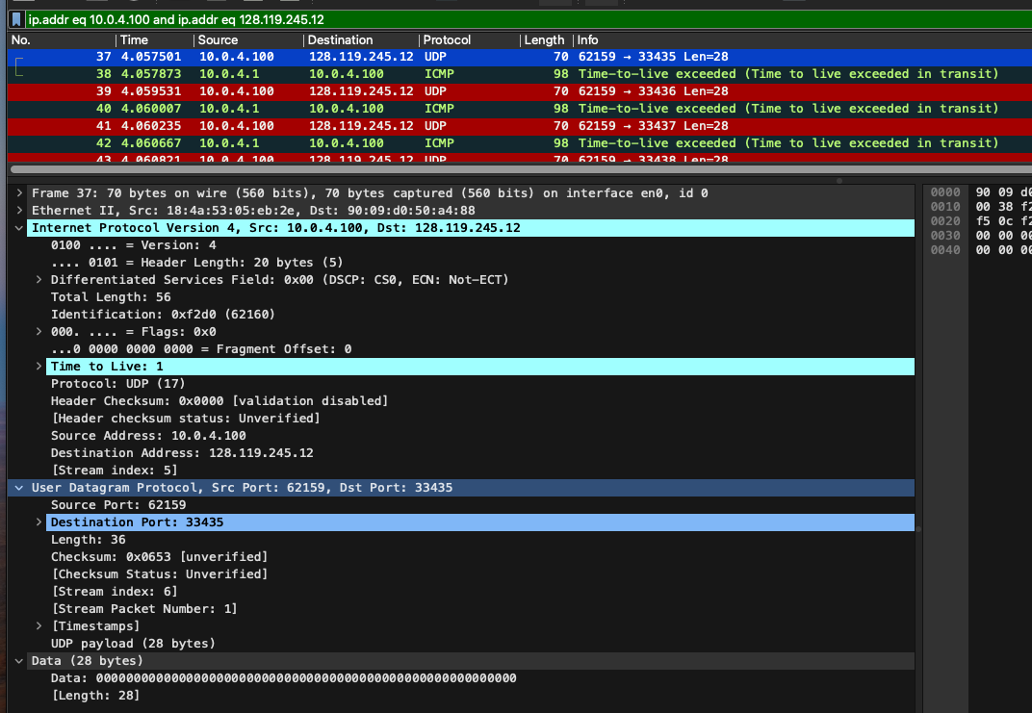

- What is the IP address of your computer?
  - 10.0.4.100
- Within the IP packet header, what is the value in the upper layer protocol field?

- How many bytes are in the IP header? How many bytes are in the payload of the IP datagram? Explain how you determined the number of payload bytes.
  - 20 bytes
  - 70 byte frame – 20 byte IP Header = 50 byte Payload
- Has this IP datagram been fragmented? Explain how you determined whether or not the datagram has been fragmented.
  - No
  - The fragmentation bit is not set.

Next, sort the traced packets according to IP source address by clicking on the Source column header; a small downward pointing arrow should appear next to the word Source. If the arrow points up, click on the Source column header again. Select the first ICMP Echo Request message sent by your computer, and expand the Internet Protocol portion in the “details of selected packet header” window. In the “listing of captured packets” window, you should see all of the subsequent ICMP messages (perhaps with additional interspersed packets sent by other protocols running on your computer) below this first ICMP. Use the down arrow on your keyboard to move through the ICMP messages sent by your computer.

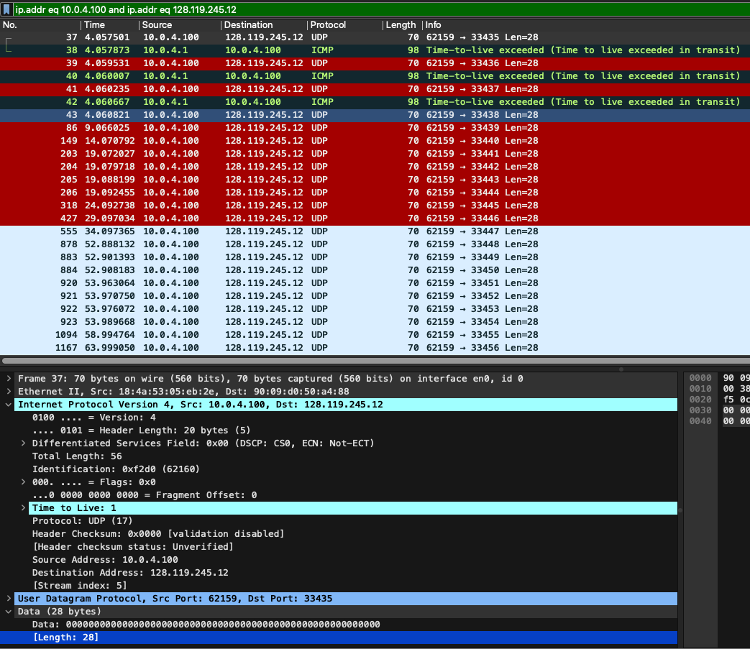

- Which fields in the IP datagram always change from one datagram to the next within this series of ICMP messages sent by your computer?
  - Frame Number, Identification and TTL
- Which fields stay constant? Which of the fields must stay constant? Which fields must change? Why?
  - Source IP, Destination IP, Protocol, Total Length, Header, Version.
  - Source IP, Destination IP, Protocol,
  - The source and destination IP cannot change due to static input.
- Describe the pattern you see in the values in the Identification field of the IP datagram
  - It is hex and increments +1 with each packet.

Next (with the packets still sorted by source address) find the series of ICMP TTL- exceeded replies sent to your computer by the nearest (first hop) router.

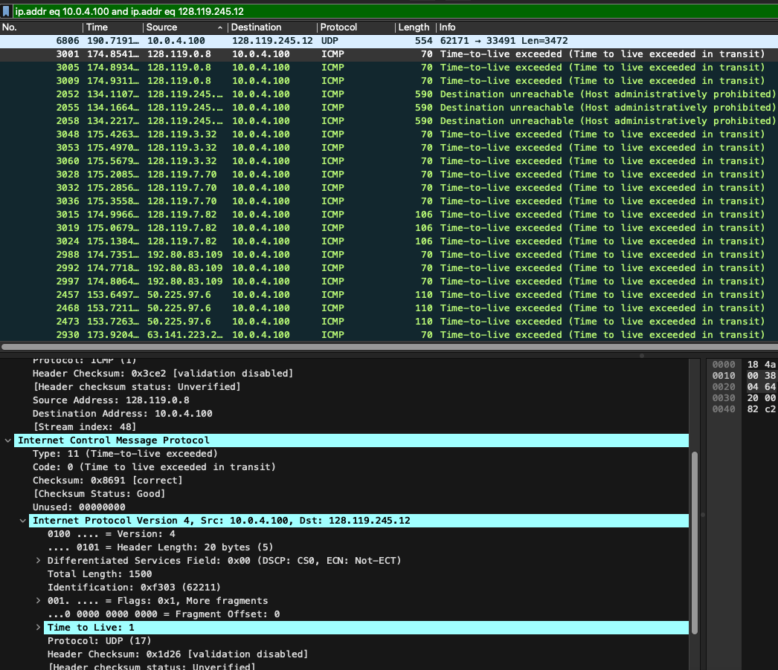

- What is the value in the Identification field and the TTL field?
  - 0x0000 (0) | 239
- Do these values remain unchanged for all of the ICMP TTL-exceeded replies sent to your computer by the nearest (first hop) router? Why?
  - Yes
  - The TTL distance never changes from the first hop router.

Fragmentation
Sort the packet listing according to time again by clicking on the Time column.
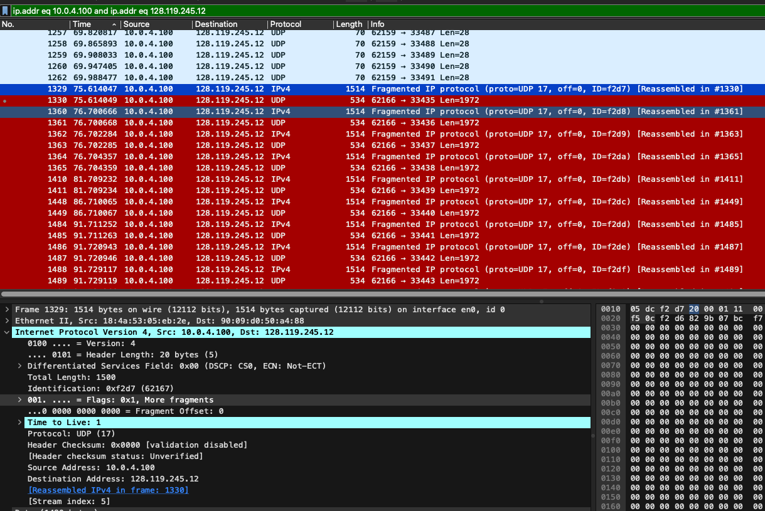
- Print out the first fragment of the fragmented IP datagram. What information in the IP header indicates that the datagram been fragmented? What information in the IP header indicates whether this is the first fragment versus a latter fragment? How long is this IP datagram?
  - Flags: 0x1, More Fragments
  - Fragment offset: 0 indicates first.

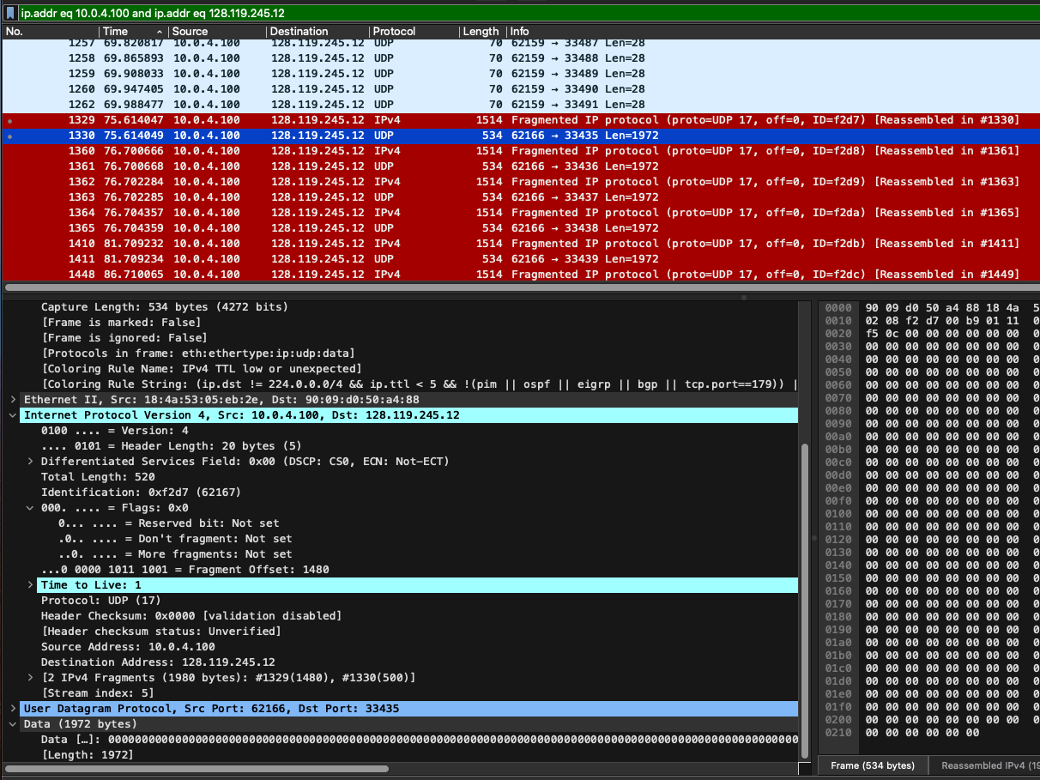
- Print out the second fragment of the fragmented IP datagram. What information in the IP header indicates that this is not the first datagram fragment? Are there more fragments? How can you tell?
  - The fragment offset has a value of the previously fragmented packet.
  - The fragmentation flag is set to 0x0 and no fragments are noted
- What fields change in the IP header between the first and second fragment?
  - Fragmentation flag, fragmentation offset, now UDP

Now find the first ICMP Echo Request message that was sent by your computer after you changed the Packet Size in pingplotter to be 3500.

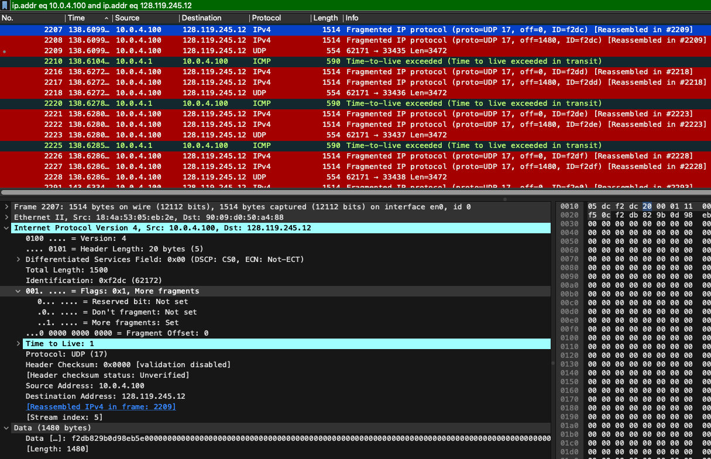

- How many fragments were created from the original datagram?
  - 3
- What fields change in the IP header among the fragments?
  - Fragmentation flag value, More fragments flag, Fragment offset, protocol.

Lab Report

Write a minimum of two type-written pages with a minimum of 12-point font describing what you learned in the lab. Do NOT simply repeat the steps you performed, summarize the purpose of the lab by explaining the concepts covered.

Your lab report will be submitted to turnitn.com. Be sure you write your report in your own words. If you don’t I will know it and you will receive zero points for the lab and face possible other consequences. Although you may work with other to compete the lab procedure, your report MUST be your original work.

In this lab I had to pay particular attention to the capture. Several times it seemed to overrun my buffer and stop or give me incomplete captures. I ended up with over 5500 packets for the three traceroutes.
After confirming I had a good data sample I began answering the questions. These questions were not necessarily looking for easily extracted values but were asking us to extrapolate the correct answer from extraneous data points that were available if you knew what you needed.

Some lessons learned were that fragmentation flag is accompanied by some other indicators such as the Fragment Offset, the last packet in the fragmentation is now UDP and that the first packet indicates that it was reassembled in frame xxxx. I had previously been unaware that the final packet changes to UDP.

This was a good exercise in reviewing that the TTL incremented for each hop and how fragmentation is handled and easily viewed in Wireshark. Once I was able to get my technical issues resolved with Wireshark and identify interfaces that respond with the needed data on a MAC it was pretty straight forward. By far the biggest challenge has been setting up an environment that I am confident will provide true data.

